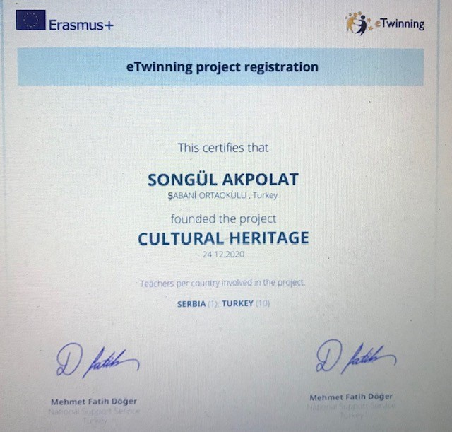
Okulumuzun" CULTURAL HERITAGE" türkçe ifadesiyle "KÜLTÜREL MİRASIMIZ "adlı e twinning projesi Türk ve yabancı ortakları ile ulusal ajans tarafından onaylanmıştır. Etkinlikleri ocak ayı itibarıyle başlayacak olan projemizde öğrencilerin ülkeleri tanıtması,kendi bulundukları bölgeleri,yöresel kıyafet ve yemeklerini ,festivallerinin-bayramlarının tanıtması gibi aktiviteler yapılacaktır.
Proje Sorumlusu:SONGÜL AKPOLAT
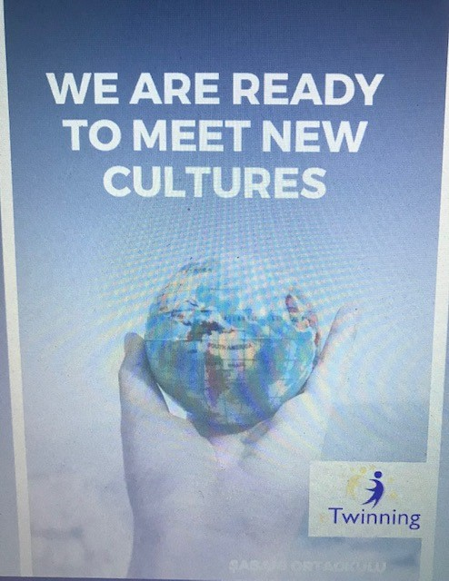
OUR CULTURAL HERITAGES
Dünyayı sarsan covid-19 virüsü sebebiyle okullarımızda uzaktan eğitime geçildi. Ve bu süreçte öğrencilerimiz arkadaşlarına ve okullarına hasret kaldılar. Öğrencilerimizin motivasyonlarını artırmak ve kültürel değerlerimizin önemini hatırlatmak için bu projeyi başlattık. Bu proje ile birlikte, öğrencilerin yaratıcılıklarını artırarak işbirliği içerisinde çalışabilecekleri bir ortam oluşturmayı amaçlıyoruz.
Due to the covid-19 virus that shook the world, distance education was started in our schools. And in this process, our students longed for their friends and schools. We started this project to increase the motivation of our students and to remind the importance of our cultural values. With this project, we aim to create an environment where students can work in collaboration by increasing their creativity.

AIMS
Our aim in this project is,
- Our students will be motivated by working in cooperation with students from different schools
- Increasing students' cultural awareness
- To help students gain self-confidence by making presentations in a foreign language
- To help them improve their foreign language skills
- To provide students with a sense of responsibility by giving various tasks
- To make them aware of cultural values ​​with the work to be done.

WORKING PROCESS
January
1. Project partners will be selected
2. Volunteer students will be selected and their permits will be obtained
3. Webinar to meet with project partners
4. Project task distribution will be made
5. Project posters, logos and banners will be prepared.
6. Social media accounts will be created and the project will be promoted on social media.
February
Bridging cultures and festivals
Each school chooses a country and compiles holidays, festivals, special occasions, superstitions and interesting information about that country and presents using Web 2.0 tools. At the end of the presentations, a quiz is conducted with the participation of all students. The school that won the quiz is chosen as the star of the month in the project. The activities will be shared by each school on the TwinSpace until the 25th of each month at the latest.

March
Local clothes and food
Each student participating in the project will wear the local clothes of their own region and introduce a dish of that region by making a video. Each school will create a collage from these video images collected. At the end of this activity, an evaluation webinar will be held and this month's star will be selected.
April
An important person from our city, region or country will be introduced by the students and if available, sketches, jokes, games will be animated using Web 2.0 tools. By making a webinar, these animations will be evaluated, the star of the month will be selected by voting
May
A video introducing the geographical features of our city or region or an interview with family elders will be prepared. An English subtitle will be added to the prepared interview or video. By holding a webinar, these works will be evaluated and the star of the month will be selected by voting.
June
A common virtual magazine including all the work in the project will be prepared. Participants will be given a certificate of participation. The quality label will be applied

EXPECTED RESULTS
Students will get to know different cultures and learn about these cultures. Our students will cooperate and interact with other students through the activities.
studies of students will be shared on social media and Twinspace

